SQL problems:

1.

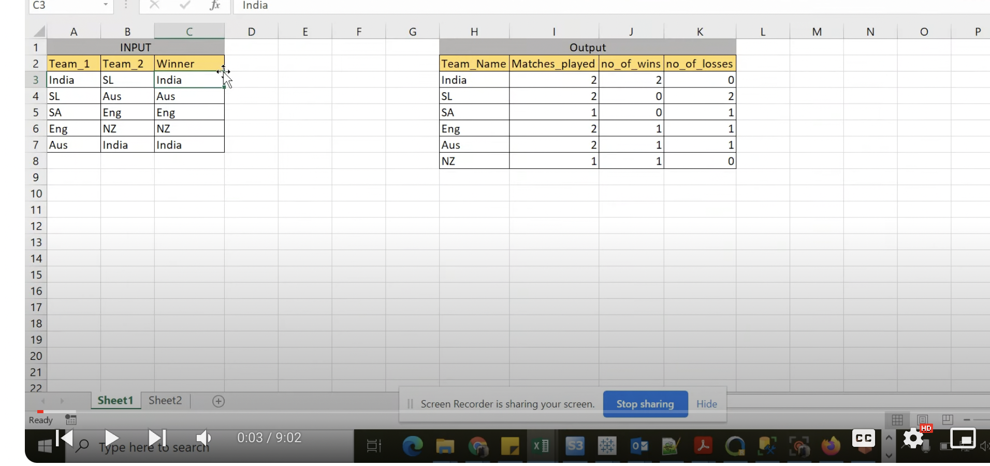

create table icc_world_cup

(

Team_1 Varchar(20),

Team_2 Varchar(20),

Winner Varchar(20)

);

INSERT INTO icc_world_cup values('India','SL','India');

INSERT INTO icc_world_cup values('SL','Aus','Aus');

INSERT INTO icc_world_cup values('SA','Eng','Eng');

INSERT INTO icc_world_cup values('Eng','NZ','NZ');

INSERT INTO icc_world_cup values('Aus','India','India');

--select * from icc_world_cup;

; with cte(team_name, win_flag) as (

select team_1, case when team_1 = winner then 1 else 0 end as win_flag

from icc_world_cup

union all

select team_2 , case when team_2 = winner then 1 else 0 end as win_flag

from icc_world_cup)

select team_name, count(1) as no_of_matches_played, sum(win_flag) as no_of_matches_won, count(1) - sum(win_flag) as no_of_matches_lost

from cte

group by team_name;

2.

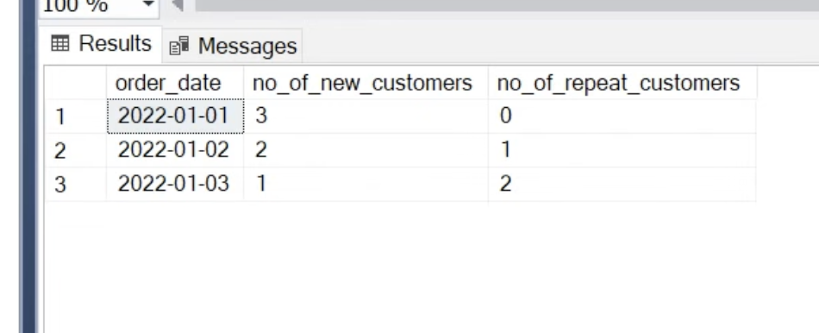

create table customer_orders (

order_id integer,

customer_id integer,

order_date date,

order_amount integer

);

select * from customer_orders

insert into customer_orders values(1,100,cast('2022-01-01' as date),2000),(2,200,cast('2022-01-01' as date),2500),(3,300,cast('2022-01-01' as date),2100)

,(4,100,cast('2022-01-02' as date),2000),(5,400,cast('2022-01-02' as date),2200),(6,500,cast('2022-01-02' as date),2700)

,(7,100,cast('2022-01-03' as date),3000),(8,400,cast('2022-01-03' as date),1000),(9,600,cast('2022-01-03' as date),3000)

;

**Solution 1:**

;with cte (order_date, r) as (

select order_date, rank() over (partition by customer_id order by order_date) r from customer_orders

),

cte1 as (

select order_date, case when r =1 then 1 else 0 end as new_flag , case when r >1 then 1 else 0 end as repeat_flag from cte

)

select order_date, sum(new_flag) as new_customers, sum(repeat_flag) as repeat_customers

from cte1 group by order_date;

**Solution 2:**

;with cte as (

select customer_id, min(order_date) as first_visit_date from customer_orders

group by customer_id

)

,

cte1 as (

select co.*, case when c.first_visit_date = co.order_date then 1 else 0 end as new_flag,

case when c.first_visit_date != co.order_date then 1 else 0 end as repeat_flag

from customer_orders co join cte c on co.customer_id = c.customer_id )

select order_date, sum(new_flag) as new_customers, sum(repeat_flag) as repeat_customers

from cte1 group by order_date;

3.

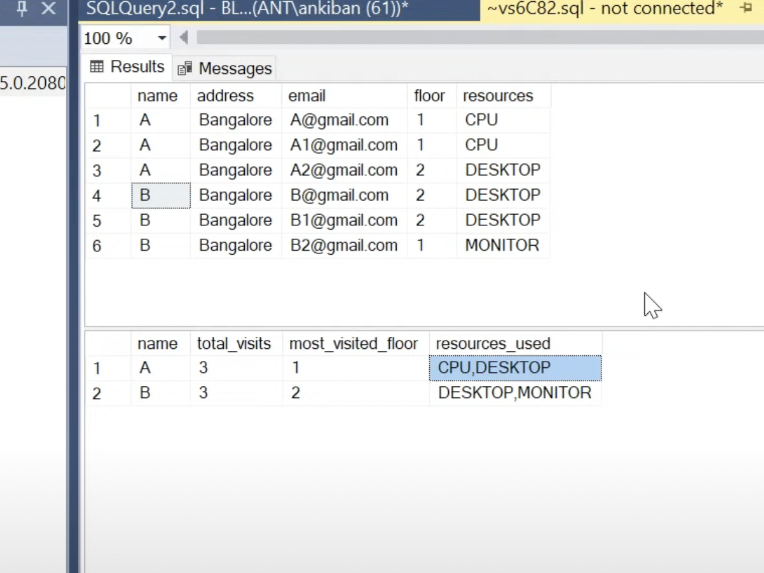

create table entries (

name varchar(20),

address varchar(20),

email varchar(20),

floor int,

resources varchar(10));

insert into entries

values ('A','Bangalore','A@gmail.com',1,'CPU'),('A','Bangalore','A1@gmail.com',1,'CPU'),('A','Bangalore','A2@gmail.com',2,'DESKTOP')

,('B','Bangalore','B@gmail.com',2,'DESKTOP'),('B','Bangalore','B1@gmail.com',2,'DESKTOP'),('B','Bangalore','B2@gmail.com',1,'MONITOR')

;WITH cte as (SELECT name, resources from entries group by name, resources),

cte1 as (select name, string_agg(resources, ',') as resources_used from cte group by name),

cte2 as (select name, floor, rank() over (partition by floor order by count(1) desc) rn from

entries group by name, floor),

cte3 as (select name, count(1) as no_of_total_visits from entries group by name)

select cte3.name, cte3.no_of_total_visits, cte2.floor as most_visited_floor, cte1.resources_used

from cte3

inner join cte2 on cte3.name = cte2.name

inner join cte1 on cte3.name = cte1.name

where rn=1

4.

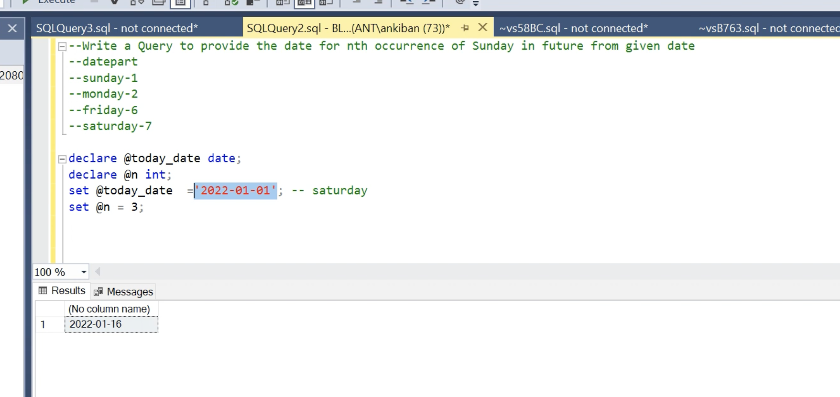

declare @d date;

declare @n int;

set @d = '2024-03-03';

set @n = 4; (**nth occurrence of Sunday after d**)

select dateadd(week, @n-1, dateadd(day, 8-datepart(weekday, @d), @d))

5. pareto principle

Create table orders (

Row_ID int,

Order_ID varchar (20)

,Order_Date varchar(50)

,Ship_Date varchar(50)

,Customer_ID varchar(20) ,Region varchar(50) ,Product_ID varchar(50),Category varchar(50)

,Sub_Category varchar(50) ,Sales float

,Quantity float,Discount float ,Profit float

)

insert into orders values

(1, 'CA-2020-152156', '08/11/20', '11/11/20', 'CG-12520', 'South', 'FUR-BO-10001798', 'Furniture', 'Bookcases', 261.96, 2, 0, 41.9136),

(2, 'CA-2020-152156', '08/11/20', '11/11/20', 'CG-12520', 'South', 'FUR-CH-10000454', 'Furniture', 'Chairs', 731.94 ,3 ,0 ,219.582),

(3, 'CA-2020-138688', '12/06/20', '16/06/20', 'DV-13045', 'West', 'OFF-LA-10000240', 'Office Supplies', 'Labels' ,14.62 ,2 ,0, 6.8714),

(4, 'US-2019-108966', '11/10/19', '18/10/19', 'SO-20335', 'South', 'FUR-TA-10000577', 'Furniture' ,'Tables', 957.5775, 5, 0.45, -383.031),

(5, 'US-2019-108966', '11/10/19', '18/10/19', 'SO-20335', 'South', 'OFF-ST-10000760', 'Office Supplies', 'Storage', 22.368, 2, 0.2, 2.5164)

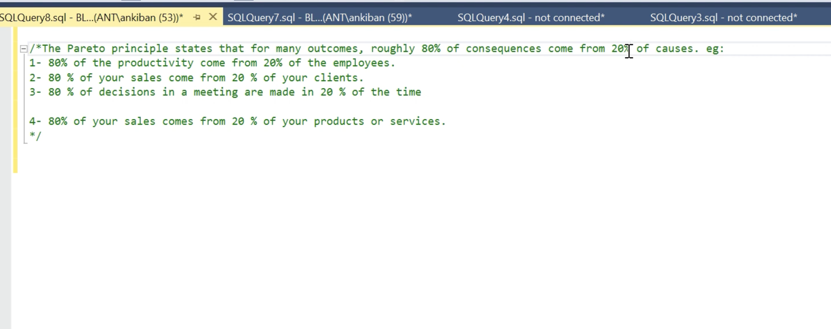

;with cte as (select product_id,sum(sales) as product_sales

from orders

group by product_id)

select * from

(select *,

sum(product_sales) over(order by product_sales desc) as running_total

from cte) A

where running_total<=(select 0.99*sum(sales) as ninetynine_percent_sales from orders)